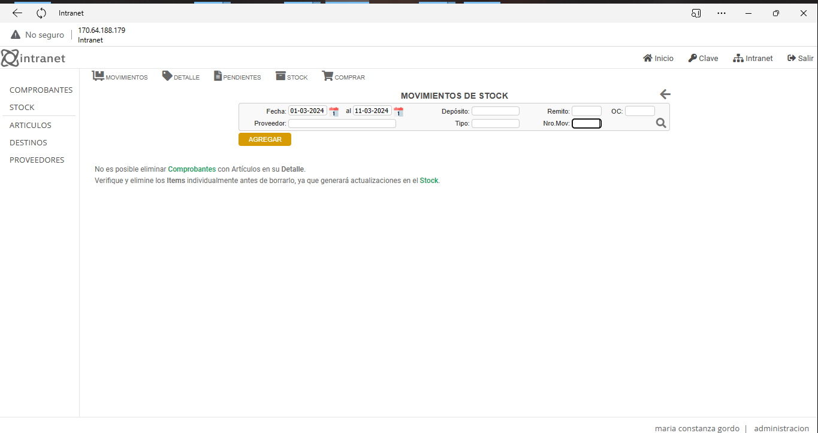

http://170.64.188.179/IntranetOAS/Stock.php

